Thank-you for taking the time to celebrate the contribution that organisations and individuals make to pro bono by submitting a nomination. If you would like further information before making your nomination read the nominations guidance on the LawWorks website.
Please note if you would like to make multiple nominations you will need to complete a new form for each individual nomination. If you would like to enter a single nomination into multiple categories select as many as required from the list below.
NB: the deadline for submission of nomination forms is midnight on Monday 5th October 2020.
Please put a by the category you would like to make a nomination for.
Best Contribution by a Small or Medium Firm
Best Contribution by a Large Firm
Best Contribution by an In-house Team or an In-house Solicitor
Best Contribution by an Individual
Junior Lawyers Division Pro Bono Award
The LawWorks Cymru Award
Best Contribution by a Pro Bono Clinic
Best International Pro Bono Award – in partnership with A4ID
Best Digital / Virtual Pro Bono Activity
Best New Pro Bono Activity
Most Effective Pro Bono Partnership

Please provide your name and contact details:
Name
Email address
Phone number
Organisation/institution
Address

Please provide the name and contact details of the person/organisation that you are nominating:
Name of the nominee
Email address
Organisation/institution
Address

Refer to the nominations information guidance page on the LawWorks website, or awards criteria section below for guidance on completing these sections.

Describe the pro bono activity undertaken (max 500 words)

Describe the impact of the pro bono activity (max 500 words)

Supporting documents
Where relevant, up to two supporting documents may be submitted with the nomination form (each limited to 500 words). The sort of documents that may be useful are references from other parties involved, letters of thanks and any other documents that provide further insight into the activity carried out.
Please read and complete the following
LawWorks will be highlighting the impact of pro bono work undertaken by students.
Please tick here if you are happy for LawWorks to use information provided in your nomination, regarding the activity and impact, in external communications.

The LawWorks Pro Bono Awards are kindly sponsored by:
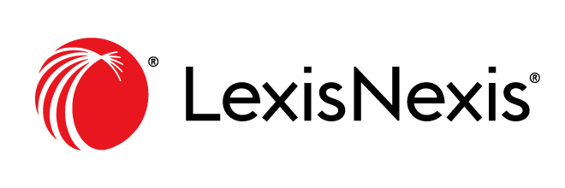

Criteria for nominations
We recognise that this has been an exceptional and challenging year due to the impact of coronavirus. In all the above categories, consideration will be given to nominations that have been responsive to the issues and legal needs presented by the Covid-19 pandemic, and overcoming barriers and challenges. This will be particularly relevant for the ‘Best Digital / Virtual Pro Bono Activity’ and ‘Best New Pro Bono Activity’ categories.
To be eligible, nominees must meet the following requirements:
- Nominees are a member of LawWorks (as of 2nd October 2020); for the ‘Best contribution by a pro bono clinic’, Best Digital / Virtual Pro Bono Activity’ and ‘Best New Pro Bono Activity’ categories, a clinic registered with the LawWorks Clinics Network can also nominate or be nominated for. Membership of LawWorks includes the partners, associates, trainees, and employees of a LawWorks member organisation.
- Except for the ‘Best international pro bono award’, the legal pro bono work was for individuals and/or organisations or communities in England and Wales (please note that this is not restricted to participation in a LawWorks project or programme). For the 'Best international pro bono award', we do require that at least one England and Wales lawyer has been involved in the pro bono work (that might, for example, include a pro bono co-ordinator in the relevant firm).
- Nominations should include evidence of benefit and impact(s). This can include:
- A description of the pro bono activity undertaken – e.g.,
- the identified need or the presenting problem(s);
- the intended beneficiaries or clients;
- the nature or type of legal work or advice given and/or action taken;
and
- the outcomes or impact(s) achieved;
- evidence demonstrating improvements for individuals or local communities, such as the number of people who have benefited from the pro bono legal work; and
- A supporting statement(s) – if possible - from a beneficiary or a partner/stakeholder.
If there is any information submitted which you do not wish to see included in a summary in the published awards brochure or would like to approve before inclusion, please mark this clearly on your nomination form.
You can nominate yourself or your own organisation or another individual or organisation.
All nominations will be judged by an independent shortlisting and judging panel, whose decision will be final.

